6.8.1 Third Party Testing Approach
This article to propose an approach for 3rd Party Testing to CDCB.

Get token by Postman
To access the API, the user needs to get a token. After getting the token, we can use that token to test the APIs in Web connect.

The Swagger API Documentation link
API Service | Links
Web application | https://40.142.54.172/api/docs
Data Exchange | https://40.142.54.172/api/data-exchange/docs
ETL process | https://40.142.54.172/api/etl/docs

Account
There’re 2 types of token:
- For Public Users: to APIs in public pages.
- For Register Users: to APIs in pages required logging in.

Public Users
- With the Public Users, they need to send a request to api/auth/public-token.
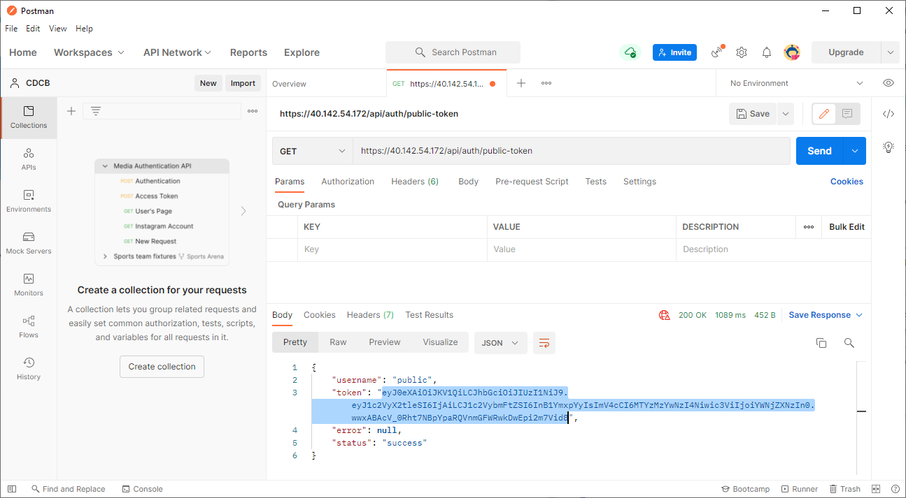
2. The result returns the token, then we can use this token to test the APIs.

Registered Users
With the Registered Users, they need to send a request to api/auth/login. Before we send a request we need to encode the password by using Base64.
Please see example below using Postman:
Step 1: Import Enviroment CDCB to Postman
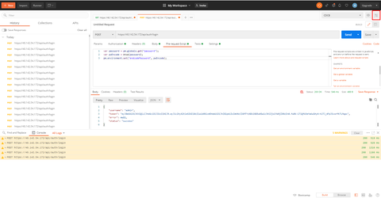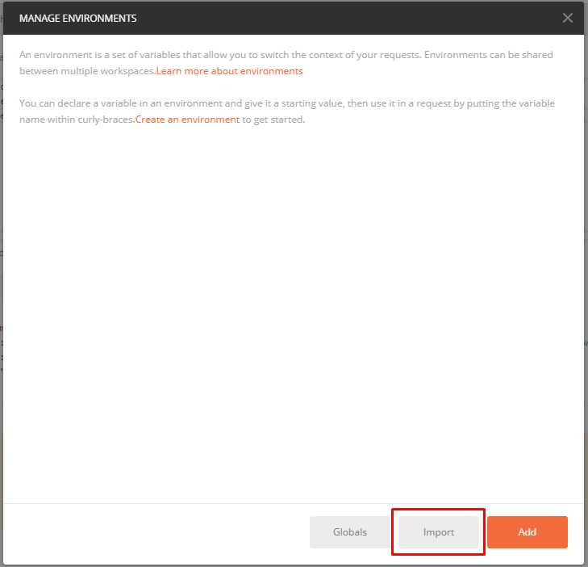

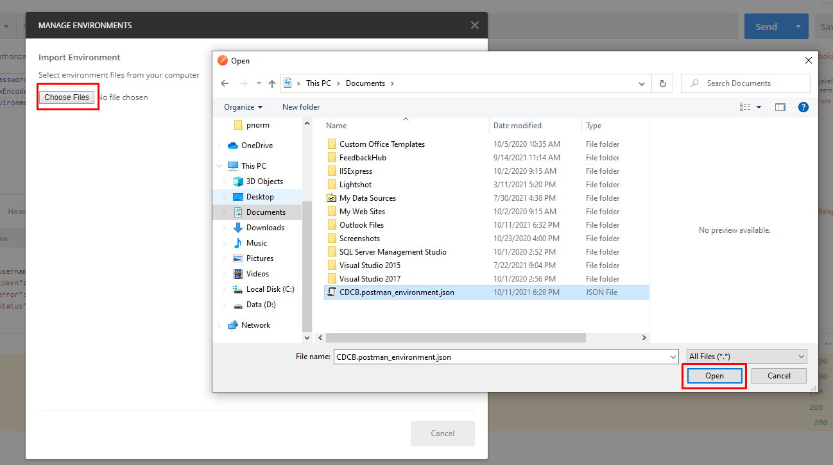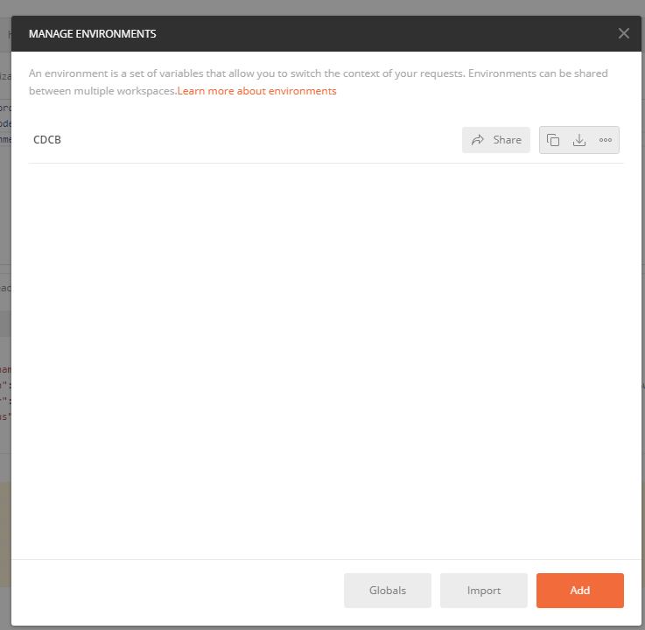
Select CDCB enviroment in dropdown list
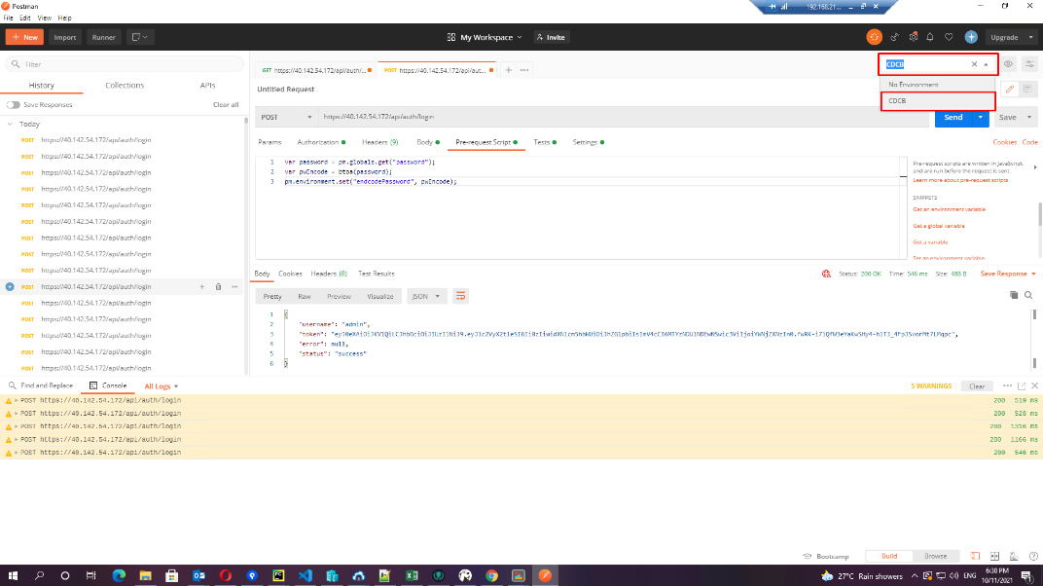
Fill out password:
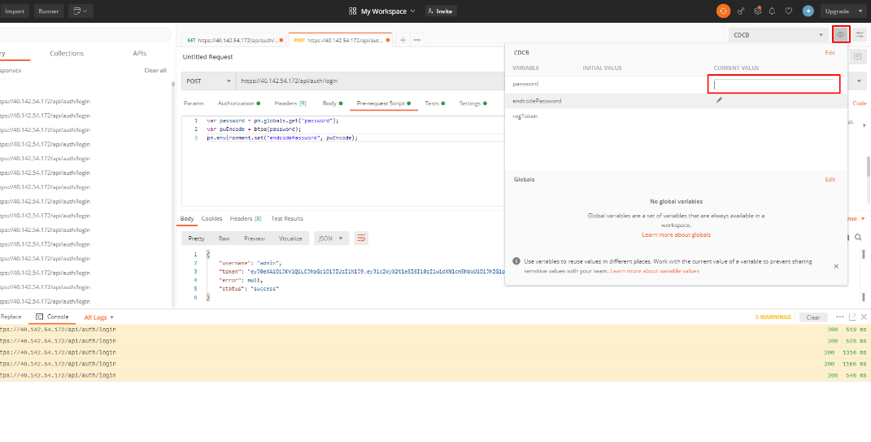
- Step 2: Setup login request with post method, input {{endcodePassword}} (the variable that defined above) to "password" property:
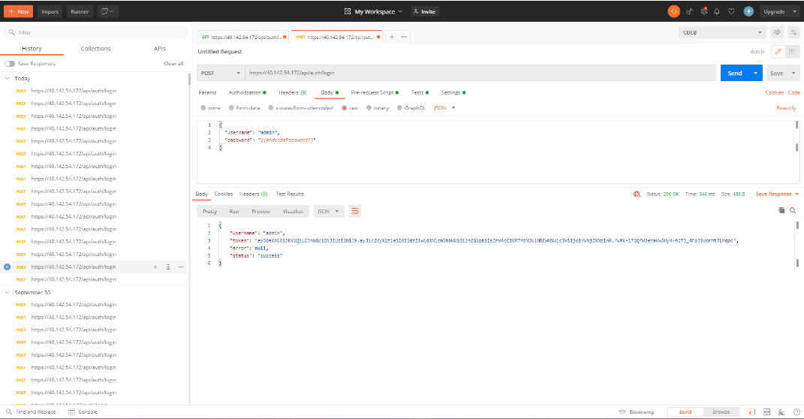
- Step 3: Add tab Pre-request Script, add code encode base64 as below:
- const password = pm.environment.get("password");
- const pwEncode = btoa(password);
pm.environment.set("endcodePassword", pwEncode);
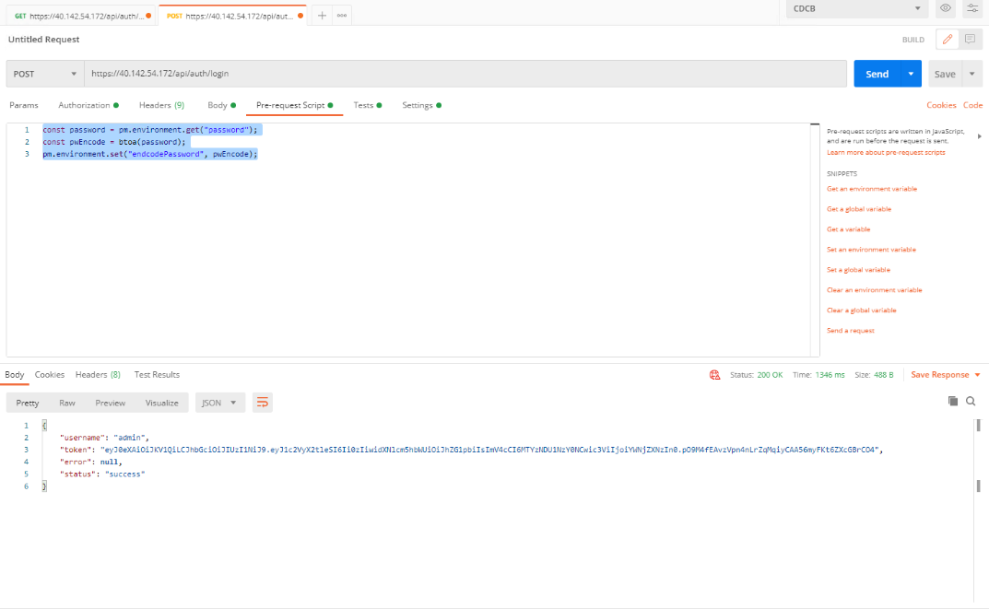
- Step 4: Add tab Tests, get response assigned to regToken
if(responseCode.code === 200){
const jsonData = JSON.parse(responseBody)
pm.environment.set("regToken", jsonData.token)
}
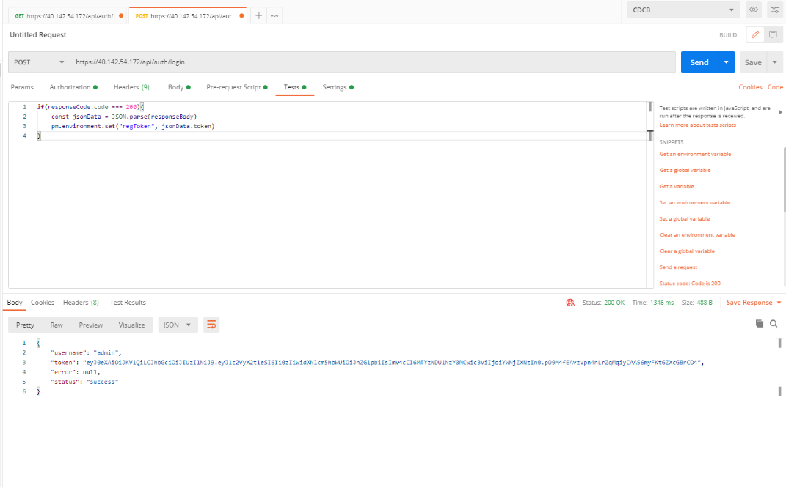
- Step 5: The result returns the token, then we can use this token to test the APIs.
