CDCB Board of Director’s Demographics

September 2025

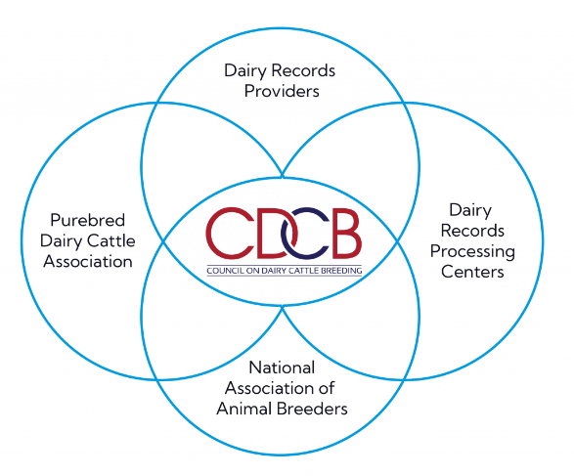

The CDCB Board represents four sectors of U.S. dairy, with each sector represented on the Board by three individuals.

Officers are elected to two-year terms by their peers on the Board of Directors.

**Board Composition**

Board Membership

12 Total Board Members

* 9 male (75%)
* 3 female (25%)

Geographic Representation

* 3 members from the West Coast
* 4 members from the Mid-West
* 1 member from the East Coast
* 3 members from the Northeast
* 1 International Board Member

Years of Service

* 3 members with 10+ years
* 3 members with 5-10 years
* 6 members with 1-5 years
* 3 founding board members