TEAM

Chair Asha Miles | USDA-ARS-AGIL
Membership Jeffrey Bewley | HAUSA
Sophie Eaglen | NAAB
Robert Fourdraine | DRMS
Kristen Gaddis | CDCB
Steven Sievert | NDHIA
Advisory Joao Durr | CDCB
Jay Weiker | NAAB, CDCB BOD
Lindsey Worden | HAUSA, CDCB BOD

In absentia: Sophie Eaglen, Steven Sievert

PROPOSED AGENDA

- New Research Results
  - SCS and milk components
    - Data table in Appendix 1
  - Clinical Mastitis
    - Data figure in Appendix 2

- Progress Report on PTAs
  - Prelim data is nearly done running, will hopefully have numbers by this meeting

Trait is MSPD averaged over all available data from 10 – 305 DIM. This means only cows with complete lactations were used, n = 21,871 (from Jan 2022 – Jan 2023).
Because of software difficulties in generated heritability using SAS, we used h² = 0.18 from literature estimate, with fixed effects of breed (HO and JE only), OEM, milking frequency, lactation number, DIM (essentially lactation length, used to choose only full lactations), and random effects of herd and cow.
PTAs generated; genetic correlation to SCS was 0.41, 0.20 to milk yield, and 0.08 to NM$. In most recent 5 years of HO bulls (n = 1,170), mean REL for MSPD was 24% (compared to 87% for SCS). A few bulls had MSPD REL as high as 76%, just depends on bull popularity and number of daughter records.

  - Considering multiple trait definitions
    - Average MS (lbs/min) over all available data
We later estimated heritability in AIREMLF90 ver. 1.148
For average MS across all available data comprising 21,871 cows (213,831 in pedigree information), h² = 0.37. REL estimates for prelim PTAs will go up recalculating with this higher heritability.
    - Average MS (lbs/min) from test-days only
This simulates what results would be like if we modified Format 4 to include time stamps/duration. We need to be mindful that on Format 4 we might get 7d average weight not individual milking weight.
**note: we should also look at primiparous only, more similar to what other countries are doing
    - A single randomly selected MS (lbs/min)
    - – vi. The same, but for milking duration (min)
This is a different trait/objective, but still important to look at.
- Review ICAR paper
  - Attached as separate document; these are the same data Steve presented for us in Spain in May, but your opportunity to review it in written form. Final version due September 29th, please return any comments by Wednesday September 27th
- Other – Open to All
  - Thoughts on content for Expo
ICAR content will be new for this audience, could summarize survey distributed at Expo last year, present new SCS and CM results, share plans for PTAs, first h² estimate.
  - Government shutdown
Be aware that this is seeming increasingly likely and will delay this research if it occurs
  - Any other comments
- Action Items:
  - Prioritize comparing PTAs from all measurements to PTAs of test-day measurements only. Goal: Make a recommendation to CDCB Board on modifications to Format 4 by December Board meeting. This will get data flowing while more fundamental research is ongoing.
  - Stratify cows into MSPD groups by standard deviation from herd mean; then look at relation to SCS and clinical mastitis.

APPENDIX

Appendix 1.

Table XX. Correlation (Pearson) of test-day SCS, Fat, and Protein with Milking Speed. Milking Speed is given as the average speed from all milkings (2-6X, depending on the cow and milking system) on the respective test-day. *P < 0.05, **P < 0.01, ***P < 0.001, †P < 0.10
 |  | SCS | Fat | Protein
Ayrshire | 2X (n = 433) | -0.41** | -0.07 | -0.29*
 | 3X (n = 0) | -- | -- | --
 | AMS (n = 335) | -0.85 | -0.14 | -0.05
Brown Swiss | 2X (n = 2640) | -0.34*** | -0.03 | -0.17**
 | 3X (n = 2614) | -0.17 | 0.22 | -0.15
 | AMS (n = 1531) | -0.35** | 0.16* | 0.23**
Cross-Bred | 2X (n = 2405) | -0.24*** | -0.33*** | -0.45***
 | 3X (n = 3942) | 0.00 | -0.03*** | -0.08***
 | AMS (n = ?) | -- | -- | --
Milking Shorthorn | 2X (n = 0) | -- | -- | --
 | 3X (n = 1400) | 0.38 | -0.42 | 0.07
 | AMS (n = 0) | -- | -- | --
Holstein | 2X (n = 31,984) | -0.02* | 0.10*** | 0.13***
 | 3X (n = 159,055) | -0.04*** | 0.04*** | 0.06***
 | AMS (n = 4079) | -0.18*** | -0.27*** | -0.29***
Jersey | 2X (n = 2248) | -0.13*** | -0.07† | -0.24***
 | 3X (n = 32,583) | -0.13*** | -0.14*** | -0.27***
 | AMS (n = 2462) | -0.01 | -0.05† | -0.03
From Robert:
What if Milking speed should be considered a 2 way trait, i.e. low milking speed versus high milking speed can equally point at higher SCC/Mastitis. The correlation analysis would wash out the low MS versus high MS results so correlation could be close to 0. What if we looked at the number of standard deviation from the mean in a herd and see how that correlates with SCC and mastitis events?
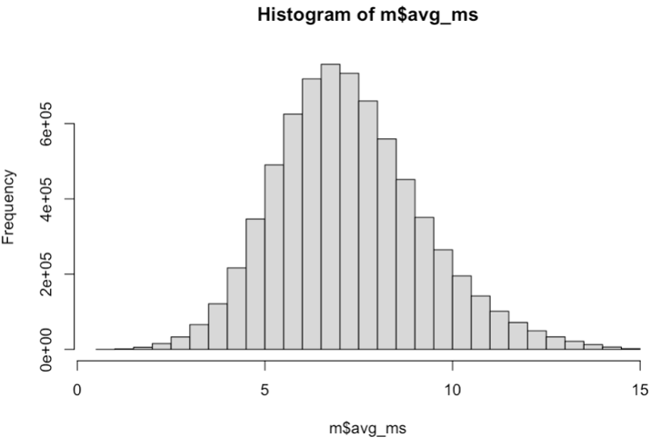
Appendix 2.

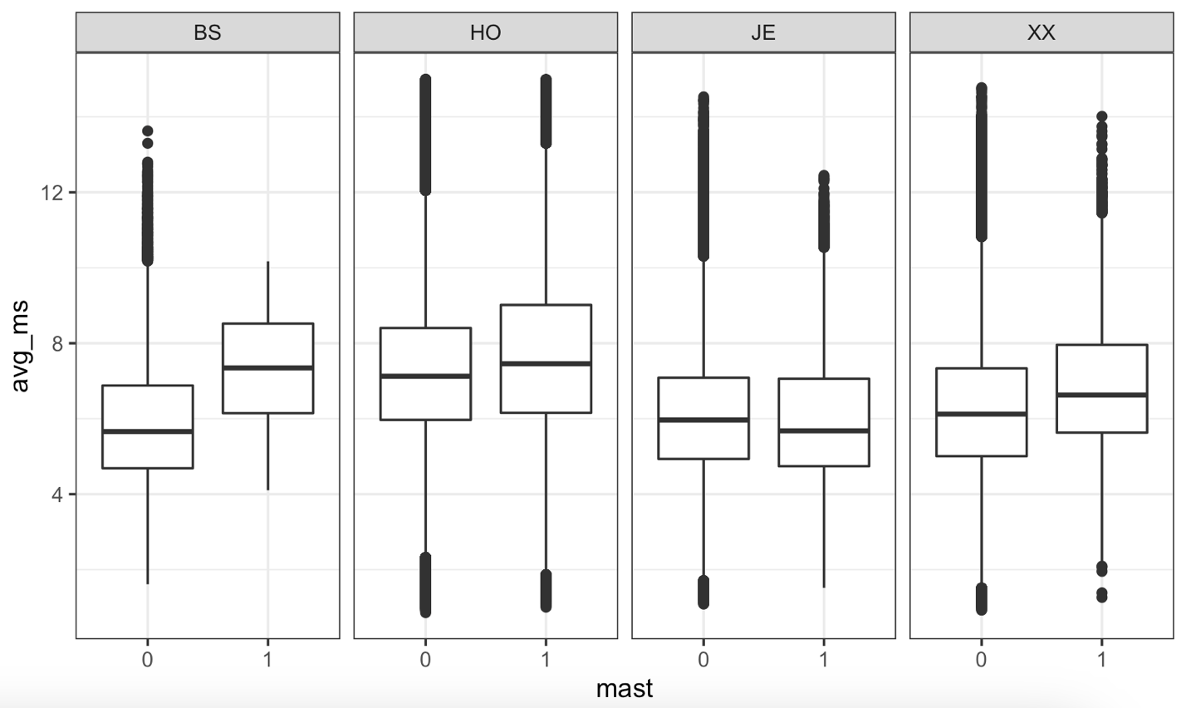
Figure XX. Differences in Milking Speed for healthy cows or with clinical mastitis diagnosis. Milking Speed is taken as the average speed from all milkings (2-6X, depending on the cow and milking system) on a given day. Cows are grouped by whether a clinical mastitis event was indicated in herd management software (1), or not and they are assumed healthy (0). No clinical mastitis events were reported for Ayrshire, Guernsey, or Milking Shorthorn in this dataset.

No statistically significant differences in the above

