TEAM

Chair Asha Miles | USDA-ARS-AGIL
Membership Jeffrey Bewley | HAUSA
Sophie Eaglen | NAAB
Robert Fourdraine | DRMS
Kristen Gaddis | CDCB
Steven Sievert | NDHIA
Advisory Joao Durr | CDCB
Jay Weiker | CDCB BOD

In attendance: Asha, Joao, Jay, Steve, Robert, Kristen, Jeffrey
In absentia: Sophie, Steve last ½

PROPOSED AGENDA

- Example data file with flow rates (Steve)
Raw data exported from the cloud can vary by OEM and nomenclatures but usually include the following information:
Header | Description
Cow_number | Herd-specific, not unique
Cow_id | Herd-specific, not unique
Meter_address | ID for specific meter in parlor
Milkingshift_id
Flow_0_15_sec | Lbs of milk during this specific time interval
Flow_15_30_sec | Lbs of milk during first 15-30sec
Flow_30-60_sec | “
Flow_60_120_sec | “
Milk_weight | Total milk yield (lbs)
Attach_duration | Time from cluster attachment to take off
Reattach_counter | Binary, yes or no
Manual_mode_count
Manual_detach_count

Flow rates are more for management insights – indicative of equipment and milker performance (udder prep, initial letdown, etc.) and will vary greatly by cow, milking event, and milkers). Nonetheless, may have effect on overall MS. Data is available with this level of precision, how useful/noisy it is TBD.

- Discuss expanded data analysis (Asha/Kristen)
  - Robert provided 7 new herds (2 AMS)
  - See data-summary below notes in comments below
  - Lead on more AMS data (Jeffrey) interested producer using GEA rotary robot

- Plan for CDCB Producer Advisory Committee Meeting
  - Brainstorm questions tabled
  - Timeline/Schedule Meeting? No rush, after PAC election in April

- Schedule next meeting/action items

What’s next?
PAC – several members mentioned they have a lot of data from their parlor & use to group cows by lactation and MS within lactations and have increased throughput by 25% by doing this
*May be willing to share some data we can add in

We want to present on these data in broader context of management insights, but also for eventual GE.

Action Items
-add more data (AMS)
Follow-up with PAC (~2+ herds)
Jeffrey will follow-up with 1 large herd
-expand analysis, especially milking interval for AMS

2b. DATA SUMMARY

Traditional Herds (n = 6)
Data cleaning
The constraints outlined in Table 1 were decided after exploratory analysis of Herd 9 only. Table 1 shows the reduction in usable data for each traditional (non-AMS) herd and the total dataset per these filtering and editing rules.

Table 1.
 | Herd 9 | Herd 1 | Herd 2 | Herd 3⁷ | Herd 4 | Herd 5 | ALL
Starting # records | 1,183,269 | 363,451 | 284,319 | 165,297 | 259,476 | 66,168 | 2,321,980
Subsetting
Holstein only | 1,173,309 | 311,607 | 269,028 | 144,555 | 197,830 | 62,294 | 2,158,623
Last 150d only | 882,561 | 296,935 | 252,625 | 139,611 | 193,608 | 61,421 | 1,826,761
Data cleaning
Milking duration¹ | 744,513 | 241,326 | 232,673 | 129,361 | 179,983 | 58,374 | 1,586,230
Milk weights² | 742,184 | 241,130 | 232,572 | 119,138 | 179,625 | 57,582 | 1,572,231
Milking speed³ | 694,827 | 235,903 | 228,793 | 115,838 | 178,642 | 57,432 | 1,511,435
DIM⁴ | 624,315 | 178,767 | 184,784 | 93,082 | 144,140 | 45,538 | 1,270,626
>10 records/cow⁵ | 622,603 | 178,028 | 183,606 | 92,790 | 143,767 | 45,362 | 1,266,156
Final # records | 622,603 | 178,028 | 183,606 | 92,790 | 143,767 | 45,362 | 1,266,156
% reduction⁶ | 29.5% | 40.1% | 27.3% | 33.5% | 25.8% | 26.1% | 30.7%
¹duration > 1 min and < 15 minutes
²milk weights >1 lb and < 60 lbs
³milking speed > 1 lb/min and < 15 lbs/min
⁴d in milk > 10 and < 305
⁵at least 10 observations per cow
⁶data lost per herd relative to bolded # of subsetted records, not starting #
⁷this was a 2X herd, all others 3X

Correlations of Milking Speed among Milkings

Table 2.
 | Herd 9 | Herd 1 | Herd 2 | Herd 3 | Herd 4 | Herd 5 | ALL
MS1:MS2 | 0.49 | 0.62 | 0.57 | 0.57 | 0.78 | 0.69 | 0.62
MS1:MS3 | 0.47 | 0.63 | 0.57 | -- | 0.77 | 0.72 | 0.61
MS2:MS3 | 0.47 | 0.61 | 0.65 | -- | 0.77 | 0.70 | 0.63

Correlations between Milking Interval and Milking Speed

Table 3.
 | Herd 9 | Herd 1 | Herd 2 | Herd 3⁴ | Herd 4 | Herd 5 | ALL
MI31¹:MS1 | -0.17 | -0.02 | -0.04 | -0.02 | -0.20 | -0.04 | -0.21
MI12²:MS2 | 0.10 | 0.01 | 0.17 | -0.01 | 0.09 | 0.29 | 0.09
MI23³:MS3 | 0.12 | 0.01 | 0.09 | -- | 0.15 | 0.06 | 0.09
¹interval between milking 3 of the prior day and milking 1 of the day of MS1
²interval between milking 1 and milking 2
³interval between milking 2 and milking 3
⁴2X herd, so MS31 is really MS21

Hypothesize that the higher correlations could be in cases where the interval is longer (for that particular herd). Need to pull out those metrics to confirm (e.g., is the longest MI for Herd 2 MI12, positive correlation suggests as MI is longer MS is faster). The absolute value of each MI was taken first, so negative correlations are not an artifact of how “time” is written/calculated across dates, they indicate an actual inverse relationship of milking interval and speed.

Correlations between Milking Speed and Milk Yield

Table 4.
 |  | Herd 9 | Herd 1 | Herd 2 | Herd 3 | Herd 4 | Herd 5 | ALL
MS1:MY1 |  | 0.56 | 0.59 | 0.46 | 0.39 | 0.62 | 0.57 | 0.58
MS2:MY2 |  | 0.59 | 0.59 | 0.46 | 0.44 | 0.61 | 0.55 | 0.53
MS3:MY3 |  | 0.57 | 0.61 | 0.43 | -- | 0.61 | 0.56 | 0.55

Milking Speed over Lactation – ALL HERDS

Edited data for all but the DIM constraints are plotted. The red dashed lines indicate DIM constraints of >10 DIM and <305 DIM. Sample Size by DIM is also plotted to show availability of data in early and late lactation.

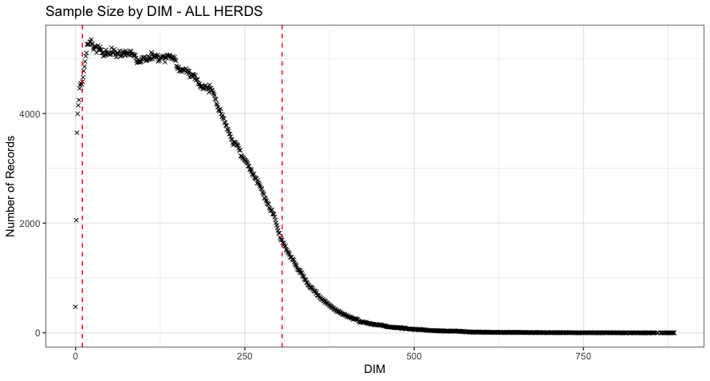

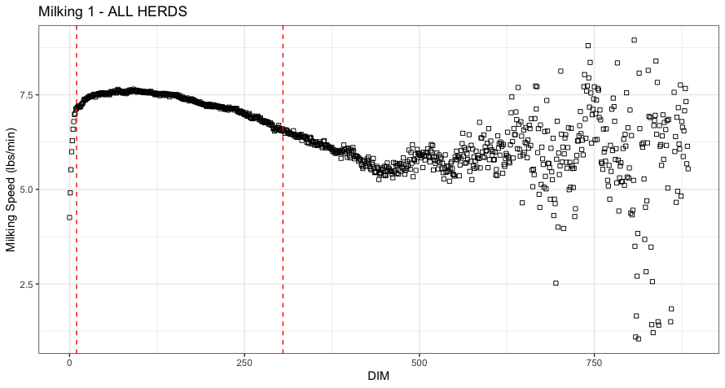
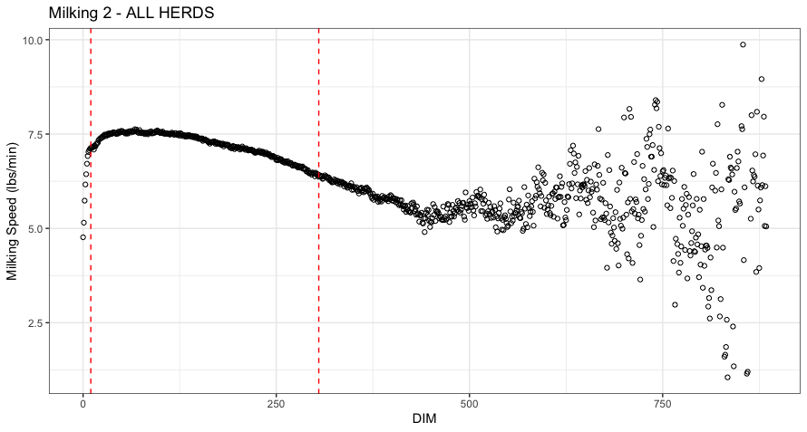
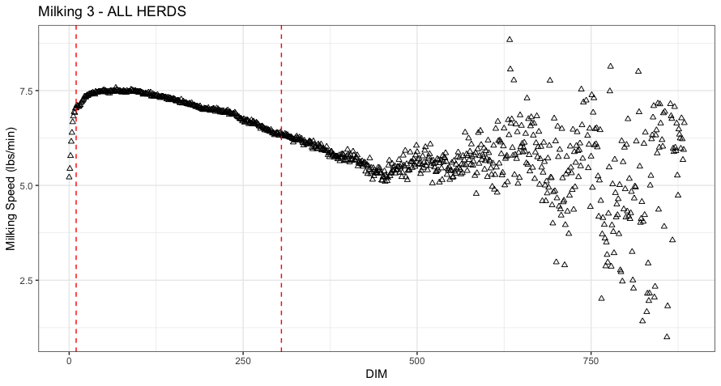
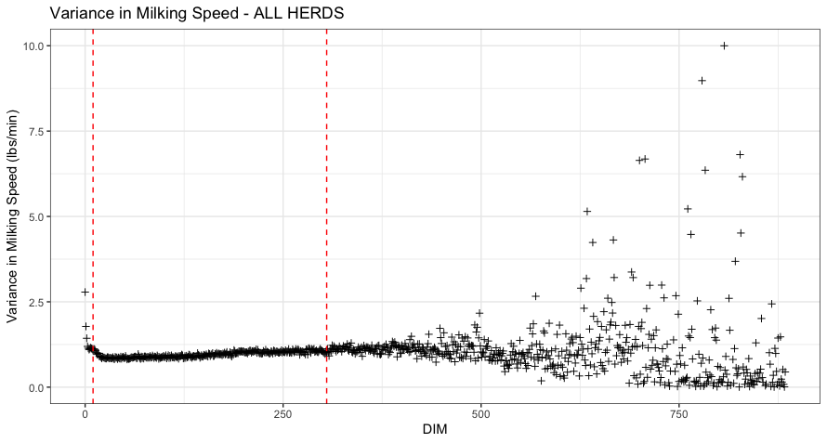

AMS Herds (n = 2)

Raw Data Summary

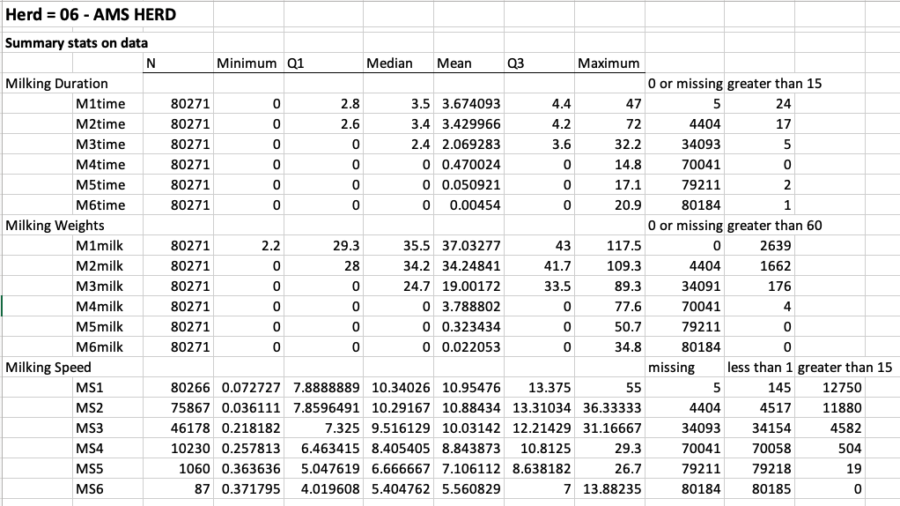
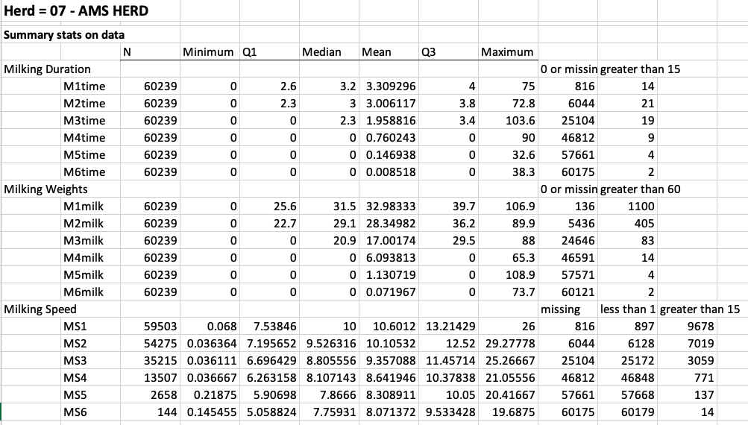

Data Cleaning
Table 5.
 | Herd 6 | Herd 7 | AMS ALL | Traditional ALL
Starting # records | 80,271 | 60,352 | 140,623 | 2,321,980
Subsetting
Holstein only | 78,871 | 53,198 | 132,069 | 2,158,623
Last 150d only | 76,329 | 39,736 | 116,065 | 1,826,761
Data cleaning
Milking duration¹ | 72,258 | 37,132 | 109,390 | 1,586,230
Milk weights² | 69,194 | 36,531 | 105,725 | 1,572,231
Milking speed³ | 54,402 | 29,480 | 83,882 | 1,511,435
DIM⁴ | 43,983 | 14,521 | 58,504 | 1,270,626
>10 records/cow⁵ | 43,545 | 14,281 | 57,826 | 1,266,156
Final # records | 43,545 | 14,281 | 57,826 | 1,266,156
% reduction⁶ | 43.0% | 64.1% | 50.2% | 30.7%
¹duration > 1 min and < 15 minutes
²milk weights >1 lb and < 60 lbs
³milking speed > 1 lb/min and < 15 lbs/min
⁴d in milk > 10 and < 305
⁵at least 10 observations per cow
⁶data lost per herd relative to bolded # of subsetted records, not starting #

Correlations of Milking Speed among Milkings

For now, these were only calculated for the first 3 milkings, as with traditional herds, given the steep drop off in sample size.
Table 6.
 | Herd 6 | Herd 7 | AMS ALL | Traditional ALL
MS1:MS2 | 0.71 | 0.54 |  | 0.62
MS1:MS3 | 0.72 | 0.56 |  | 0.61
MS2:MS3 | 0.73 | 0.62 |  | 0.63

Correlations between Milking Interval and Milking Speed

Table 7.
 | Herd 6 | Herd 7 | AMS ALL | Traditional ALL
MI31¹:MS1 |  |  |  | -0.21
MI12²:MS2 | 0.26 | 0.26 |  | 0.09
MI23³:MS3 |  |  |  | 0.09
¹interval between milking 3 of the prior day and milking 1 of the day of MS1
²interval between milking 1 and milking 2
³interval between milking 2 and milking 3

Correlations between Milking Speed and Milk Yield

Table 8.
 | Herd 6 | Herd 7 | AMS ALL | Traditional ALL
MS1:MY1 | 0.50 | 0.59 |  | 0.58
MS2:MY2 | 0.52 | 0.60 |  | 0.53
MS3:MY3 | 0.49 | 0.60 |  | 0.55
¹interval between milking 3 of the prior day and milking 1 of the day of MS1
²interval between milking 1 and milking 2
³interval between milking 2 and milking 3

Milking Speed over Lactation – ALL HERDS

Edited data for all but the DIM constraints are plotted. The red dashed lines indicate DIM constraints of >10 DIM and <305 DIM. Sample Size by DIM is also plotted to show availability of data in early and late
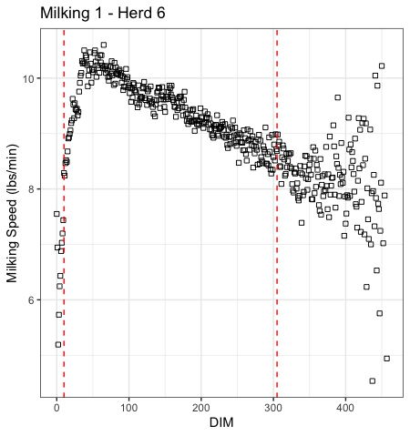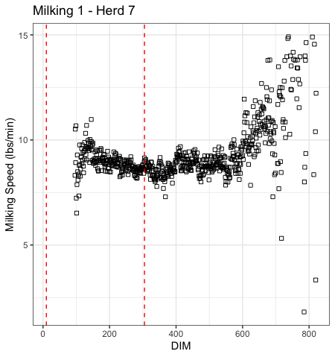

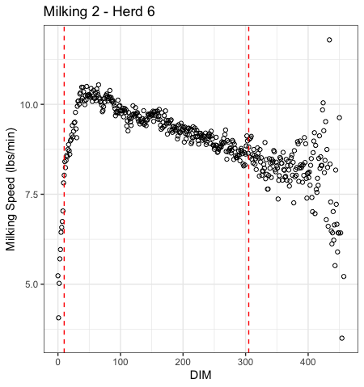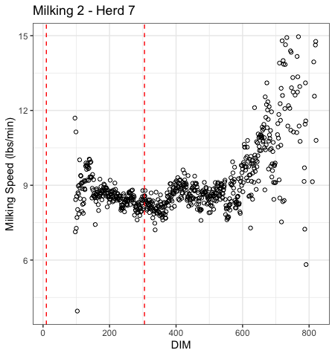

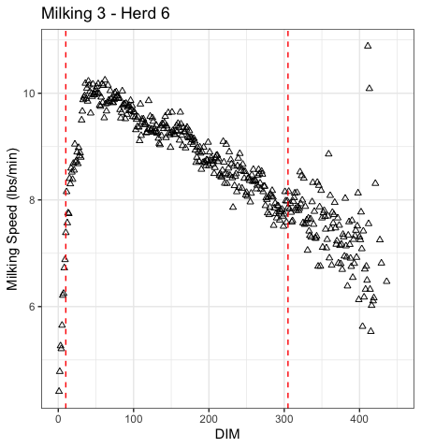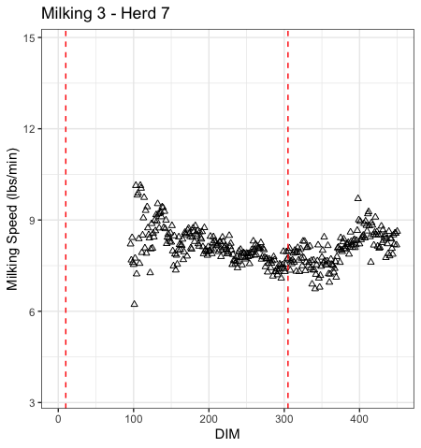

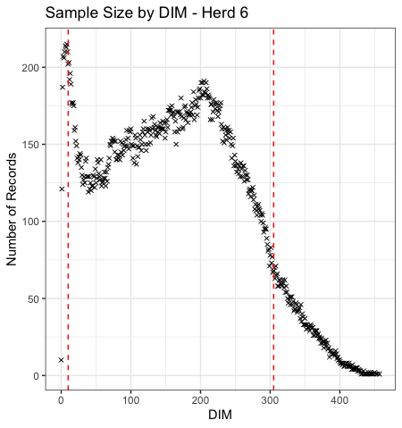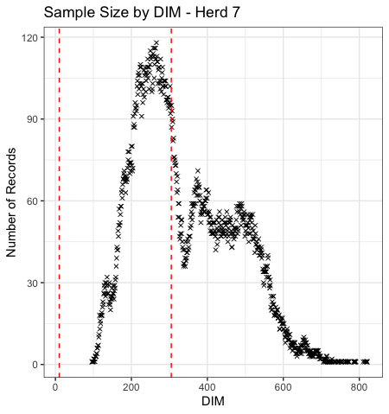

In AMS system you change feed tables based on DIM, tend to be strict cut offs that don’t follow a curve (can create some of these dramatic changes in sample size – issue of feed availability)

